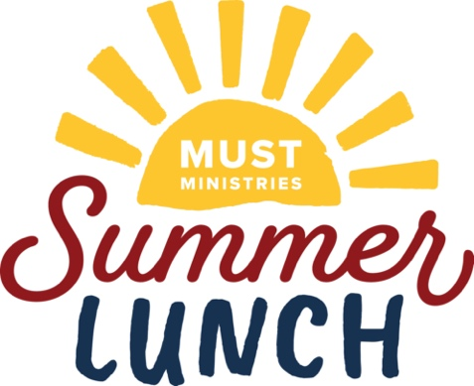
MUST Summer Lunch 2022
Mind, Body, Soul Activity Kits

Outdoor Activity Ideas –
- Beach Ball (still in packaging)
- Outdoor chalk
- Bubbles
- Squirt gun
- Small frisbee

Indoor Activity Ideas –
- Playdough
- Card games (Old Maid, Go Fish, Memory Game, Uno)
- Coloring book
- Small pack of crayons
- Puzzles
- Pop-its
- Craft kits

School Supply Ideas –
- 12 count pack of Crayons
- Pencils
- Erasers
- Pencil sharpener
- Highlighter
- Scissors
- Markers
- Glue stick

Please put 3 items into a 1-gallon zip lock bag. Please label “MUST Summer Lunch” when dropped off at the Donation Center located at 1280 Field Parkway Marietta, Ga 30066 Open Tuesday – Saturday 9a.m. – 5p.m.

Also, we need kids’ books to be donated at the donation center marked “MUST Summer Lunch”.

