Texas Renaissance Festival
Wedding Venues

The English Garden

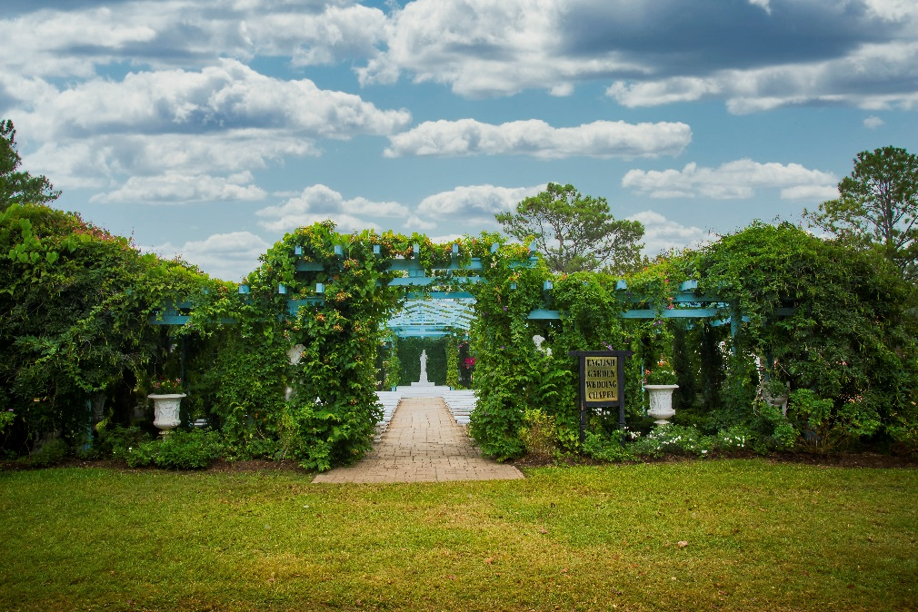
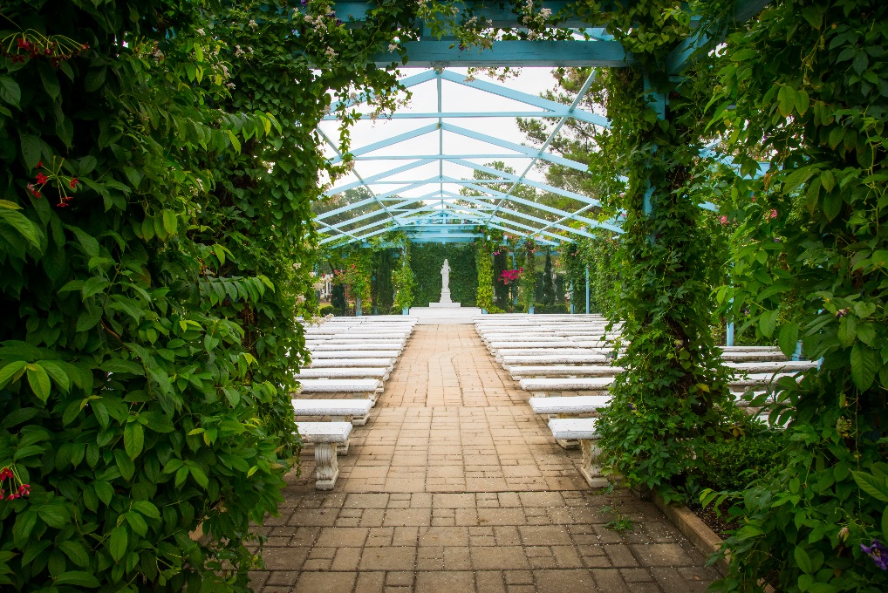

Titania, Queen of the Fairies, had this English Garden constructed to attract the attention of jealous King Oberon. This wonderful bower features over 3000 annuals, perennials, tropicals, and vines. The structure is painted a celestial blue which almost blends into the heavens above. With over 600 plants overflowing the 35 urns and statues, it’s a wonderful place to dream and exchange your vows.

Seating: 200 guests plus a wedding party of up 12

The Rose Garden

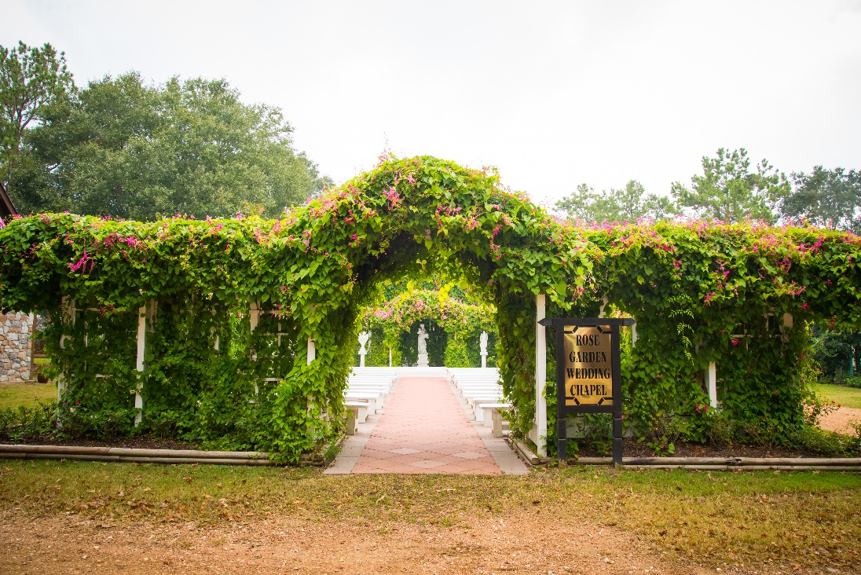
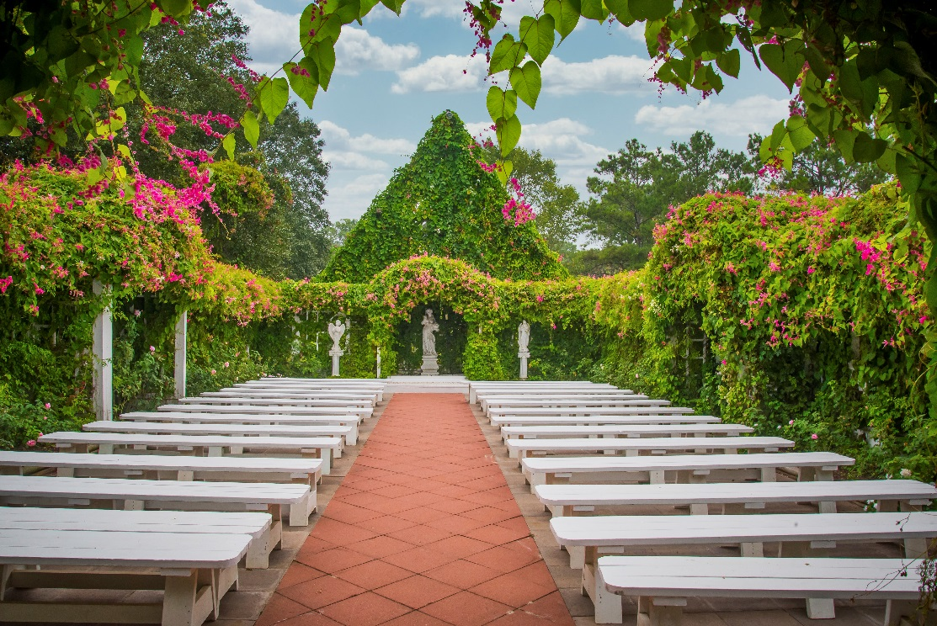

The Wars of the Roses, a series of English civil wars fought by the Houses of York and Lancaster, symbolized by the white (York) and red (Lancaster) rose, had come to an end. In tribute to the war, King Henry VIII commissioned his craftsmen to construct the Rose Garden. This garden features over 600 roses with well over 50 cultivars of fragrance and beauty. Hybrids, climbers, and miniature roses adorn the garden.

Seating: 150 plus a Wedding Party of up to 12

The Basilica

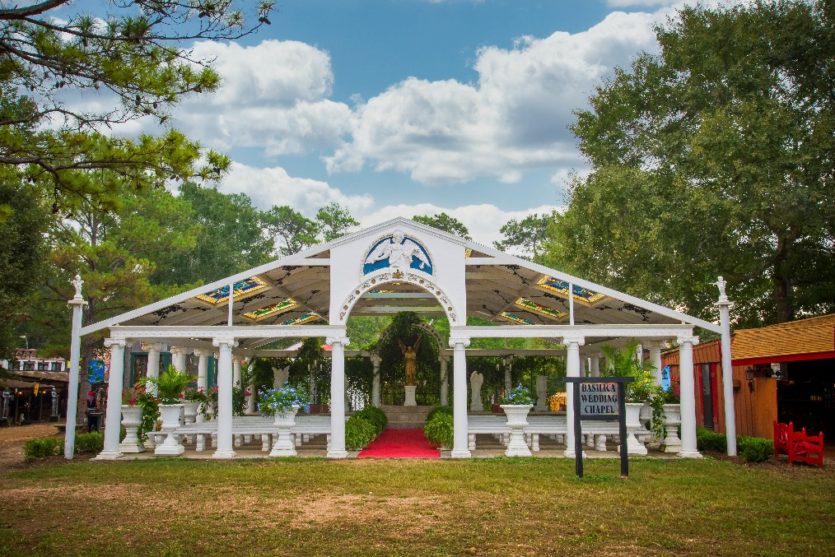
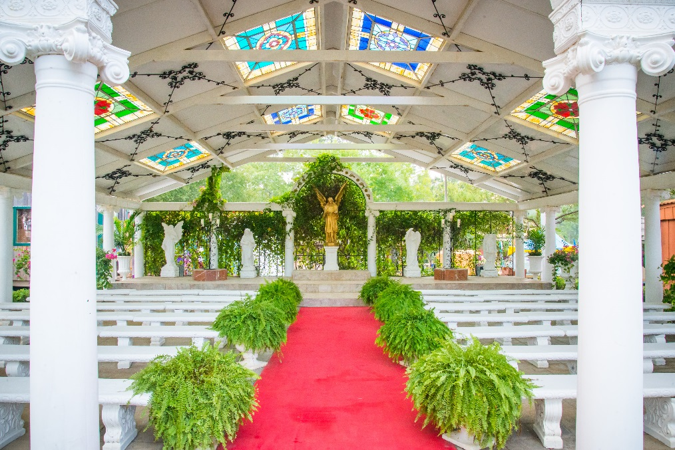

The Roman invaders erected a temple to Aphrodite, the Goddess of Love, upon New Market Village’s prehistoric battle mound, site of many great battles of ages past. Graceful arches atop slender white columns surround this sacred space. The apse is covered in Italian marble while urns overflowing with plants and flowers add to the beauty. Our golden angel, a reproduction and replica of actual Roman statuary, overlooks the bridal party as they exchange their vows.
The chapel was covered with a new roof, which features beautiful original designed stained-glass windows and inset iron filigrees. Above the entrance, a lunette graces the pinnacle of the gran doorway. It is an exact copy of a lunette made in Florence by Della Robbia in 1475, depicting the Archangel Michael wielding a sharpened sword and the legendary scales of justice. It reminds all to weigh the consequences of their actions as Michael weighs souls in the heavenly balance.

Seating: 120 guests plus a Wedding Party of up to 14

The King’s Chapel
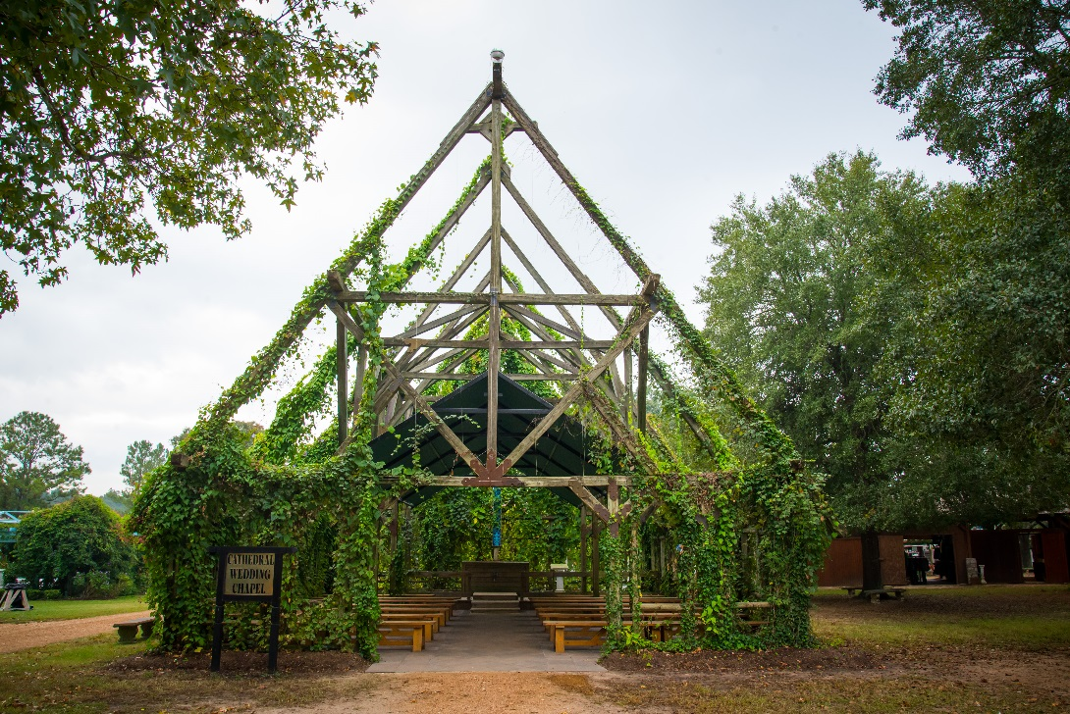
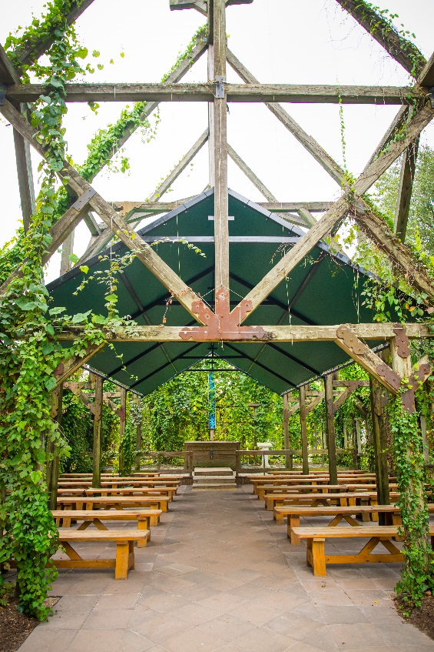

Harkening back to the early days of Celtic England, this verdant and lush open-air sanctuary brings to mind all images of the Green Man and the natural beauty of the British Isles. The chapel’s open walls and rafters become ensconced in four different varieties of flowering vines throughout the year to offer a breathtaking green covered chapel in which to pledge your unending love to your betrothed. The beautiful blue Celtic cross offers a traditional backdrop for the wedding party. This is our most popular wedding venue and has hosted hundreds of ceremonies. The chapel’s history and ambience enchant guests and wedding parties.

Seating: 90 guests plus a Wedding Party of 10

The Water Garden

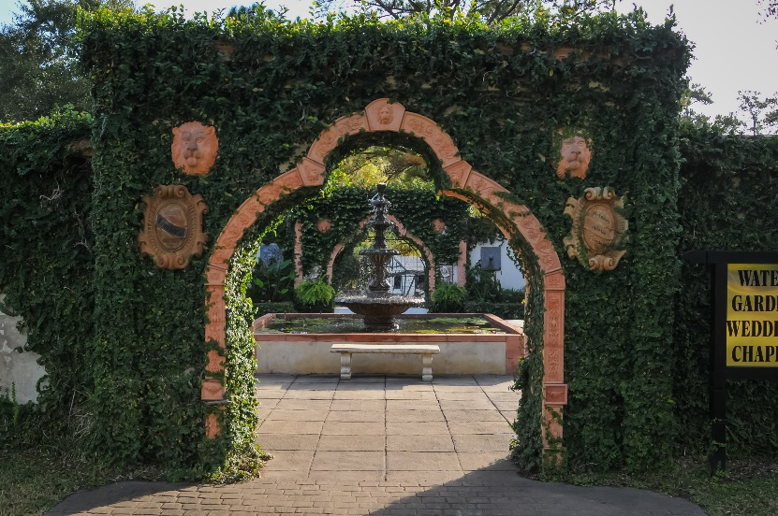
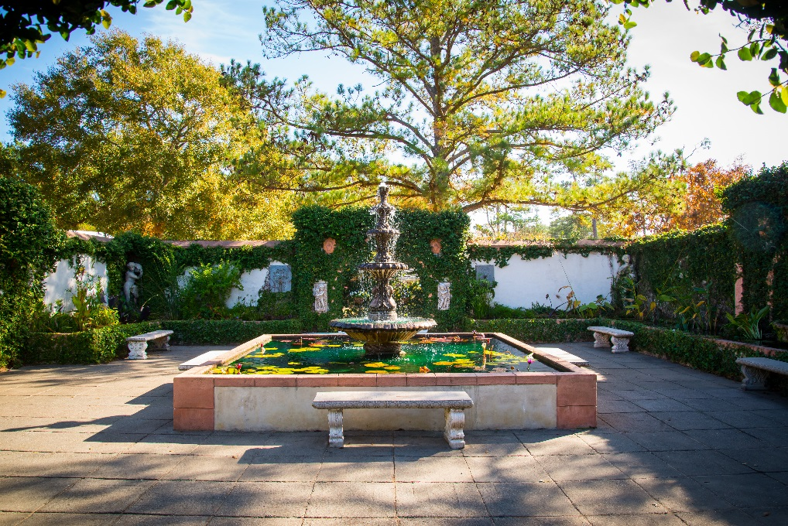

Inspired by Ponce de Leon and his legendary search for the Fountain of Youth, this garden features 19 statues and fountains that are surrounded by hundreds of luscious flowering water plants. Its construction highlights a Venetian form of architecture.
Come and enjoy the soothing sounds of the water and the sights of the flourishing vegetation.

Seating: 30 guests plus a Wedding Party of 6

