2023 Texas Renaissance Festival
New Vendor Application

The Texas Renaissance Festival offers its patrons unique quality services and products. TRF is the largest Renaissance theme park in the United States attracting more than 450,000 patrons each year. Guests are transported back to the 16th century to experience world-renowned entertainment. The 2023 Festival season dates are eight consecutive weekends from October 7th through November 26th including the Friday after Thanksgiving. Vendors are required to participate in the full run of the festival.
Please complete the vendor application and include it with your proposal. The proposal should be bound or in a binder, contain pictures and prices of all your products, a brief bio about yourself and/or your business, and a listing of any faire or festivals you have done or will be doing this year. Samples of your products or wares are encouraged but will not be returned. Mail the completed submission to TRF, attention Vendor Coordinator, 21778 FM 1774, Todd Mission, Texas 77363.
A $50.00 non-refundable application fee made payable to TRF must be included with the proposal. Submissions received without the fee will not be accepted or returned.

All applicants will be notified by email of your acceptance or denial. Items not approved by the jury will not be allowed to be sold at the festival.

Shoppe structures whether they be permanent or temporary, must be Renaissance period- appropriate and must be approved by the Vendor Coordinator.

If accepted to TRF you will receive an email containing our rules & regulations, a participant handbook, our building standards, your acceptance letter, a map with your location clearly marked, and your contract. You will have approximately 30 days to pay your vendor fees. The contract we offer becomes null and void if your required fees are not paid within the allotted time.

Lori Wright, Vendor Coordinator
21778 FM 1774
Todd Mission, Texas 77363 vendors@texrenfest.com (281) 356-2178

2023 Vendor Application
Application Fee: $50.00 - Applications submitted without payment
will not be considered.

Form of Payment included:
Name
Business Name Shoppe Name Category Address

Sales Tax ID Phone/Mobile Email
Website

Cash Check Money Order Debit/Credit Card
Exp / CVV Zip Code

- LLC
□ Registered Partnership Agreement
□ Sole Proprietorship

- Corporation

Where did you hear about this opportunity?

Description of Arts/Crafts, Service, or Merchandise:

Interested in buying or building a permanent shoppe □
List of available shoppes for sale can be found on www.texrenfest.com in our Vendor section. There may be a limited amount of spaces available to build a new booth. See the Vendor Coordinator for additional information.

Applying for a space to feature a temporary structure:
- Cart | - Tent | - Kiosk
Vendor must provide the structure and if using a tent, a floor/deck/platform will need to be built.

- I am interested in demonstrating at the festival
Please further explain how you wish to demonstrate:

Are you able to provide product/services for the full 8 weekend run? □ Yes □ No

Do you have a contingency plan for a rainy season?
- Yes | - No

Income Projections:
Expense Budget:

1st Year
1st Year

2nd Year
2nd Year

3rd Year
3rd Year

How do you plan on making a positive impact on our patrons' visit?

Texas Renaissance Festival is a juried show, please describe below which items you wish to sell or services you wish to provide.
 |  |  | TRF Use Only
Item/Provided Service | Price | % Handcrafted by Vendor | Approved Yes/No
- 100% Handcrafted
- At least 50% Handcrafted
- Manufactured/Imported
- 100% Handcrafted
- At least 50% Handcrafted
- Manufactured/Imported
- 100% Handcrafted
- At least 50% Handcrafted
- Manufactured/Imported
- 100% Handcrafted
- At least 50% Handcrafted
- Manufactured/Imported
- 100% Handcrafted
- At least 50% Handcrafted
- Manufactured/Imported
- 100% Handcrafted
- At least 50% Handcrafted
- Manufactured/Imported
- 100% Handcrafted
- At least 50% Handcrafted
- Manufactured/Imported
- 100% Handcrafted
- At least 50% Handcrafted
- Manufactured/Imported
- 100% Handcrafted
- At least 50% Handcrafted
- Manufactured/Imported
- 100% Handcrafted
- At least 50% Handcrafted
- Manufactured/Imported
- 100% Handcrafted
- At least 50% Handcrafted
- Manufactured/Imported
- 100% Handcrafted
- At least 50% Handcrafted
- Manufactured/Imported
- 100% Handcrafted
- At least 50% Handcrafted
- Manufactured/Imported

Texas Renaissance Festival 21778 FM 1774
Todd Mission, TX 77363

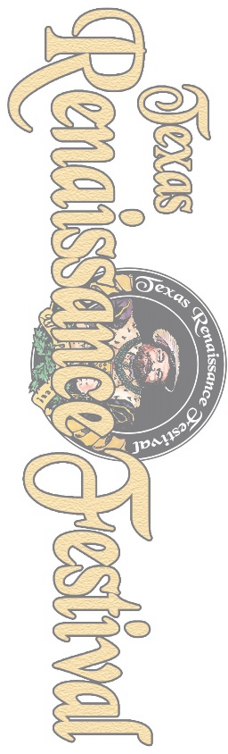
Texas Renaissance Festival 2023 Fee Schedule
Fees are for the entire run of the eight-week season
Permanent Structures
Vendor Type | Description | 2023
Artisan | Wares are 100% designed and crafted by the artist | $1,700.00
Partial | 50/50 mix of handmade and buy/sell. Also, for designers whose shop is full of their product but is produced overseas or in a manufacturing  facility. | $2,300.00
Merchant | 100% Buy/Sell | $3,000.00
Per Cap | Food & Beverage, Games & Rides | 20% Gross
Per cap | Photography, Costume and Wheelchair/Scooter rentals | 15% Gross
Commission | Lockers | 20% Gross
Demo Vendor providing APPROVED historical/artistic demonstrations in TRF owed booths Waived
Non -Permanent Structures
Vendor Type | Description | 2023
Artisan | Wares are 100% designed and crafted by the artist | 1200/1700
Partial | 50/50 mix of handmade and buy/sell. Also, for designers whose shop  is full of their product but is produced overseas or in a manufacturing facility. | Kiosk/Cart $1,500 Tent/Gazebo $2,300
Merchant | 100% Buy/Sell | Kiosk/Cart $1,800 Tent/Gazebo $3,000
Service Provider | Mystic Arts/Hair braiders/Face Painters | TBD by location

Fee Type | Description | Fee
Electric | Up to 20amps - Not available in all areas | $390.00
RV |  | $390.00
Water/Sewer | Apartments/living quarters or food/beverage | $100.00

Every 10' over 30'
$500.00
$700.00
$900.00

